

In this SEO work report We will be checking all the important matrices to measure website performance in search engine, We will be covering Search Console, Google Analytics performance, Heat Map, Keywords Ranking and Working Report. So lets first see the Google Search Console report.

# **List view Report Crazyegg Desktop**

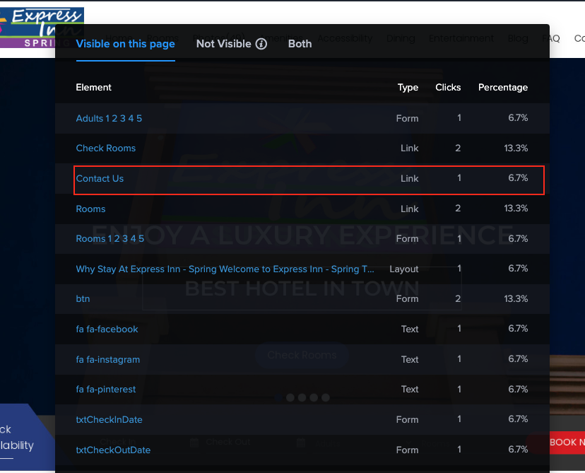

# **List View Report Crazyegg Mobile**

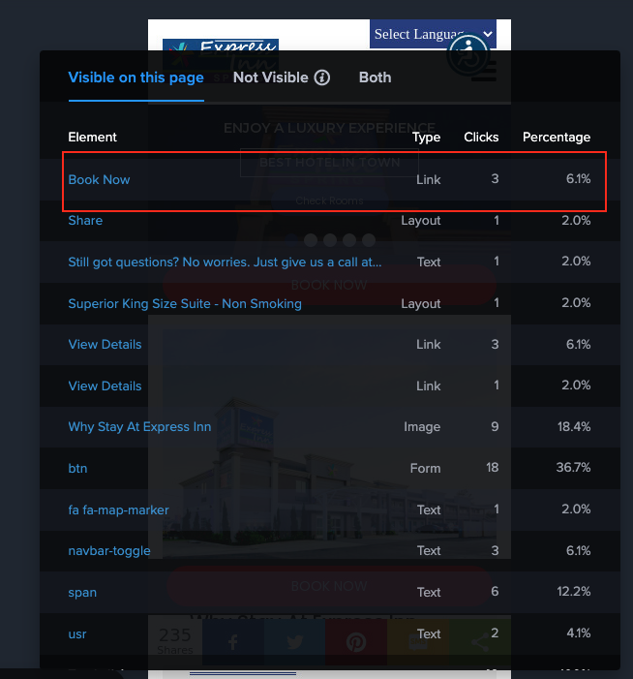

# **Heat Map Report**

Total Clicks We got On Website Based on Heat Map Report from Desktop, Mobile & Table.

**Device Visits Clicks**

Desktop 21 19

Tablet 3 1

Mobile 131 58

# **Mobile View Popularity Score**

**Referrer Clicks**

Below are the reports that shows referrer clicks, we can see different sites from where we get clicks.

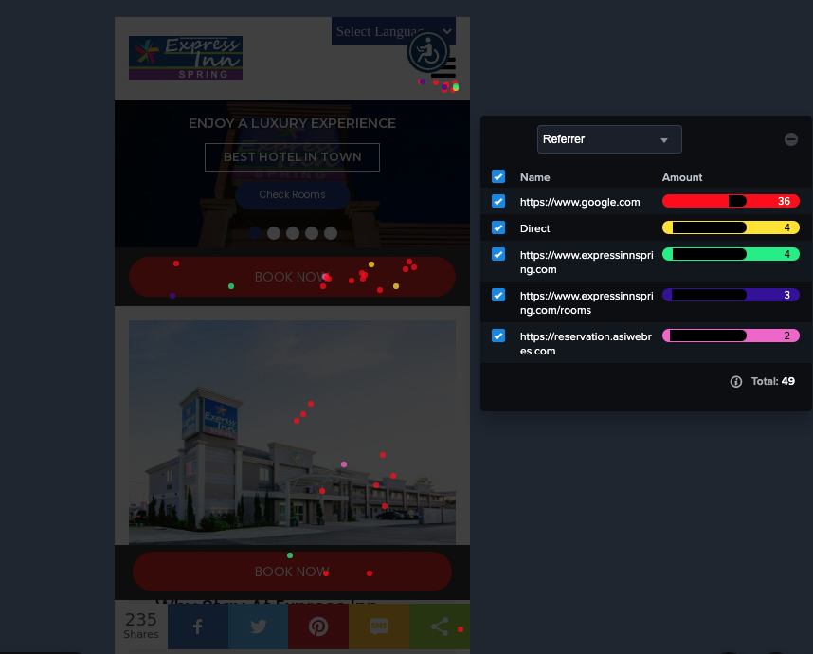

**Country**

Below is the country wise visitors reports in which we can see we get most of the visitors from USA.

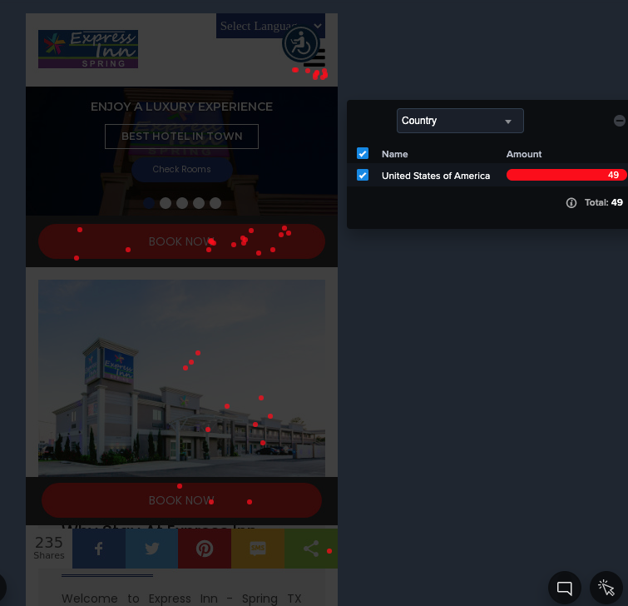

**New Vs Returning**

On Below screenshot we can see new vs returning visitors.

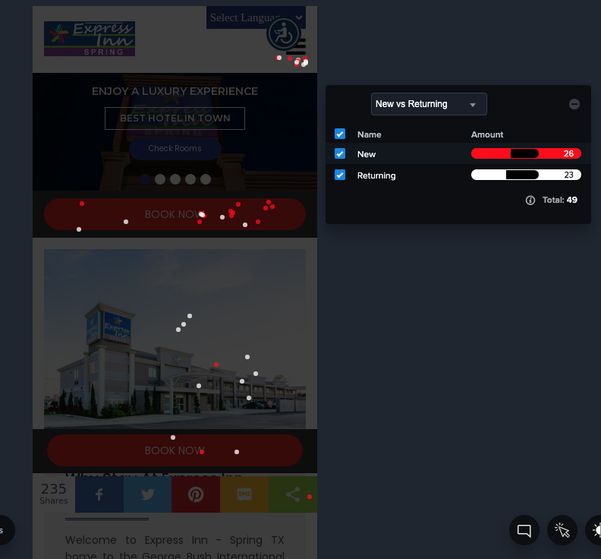

**Search Engine**

Below is the screenshot where we can see from which search engine we got the visitors.

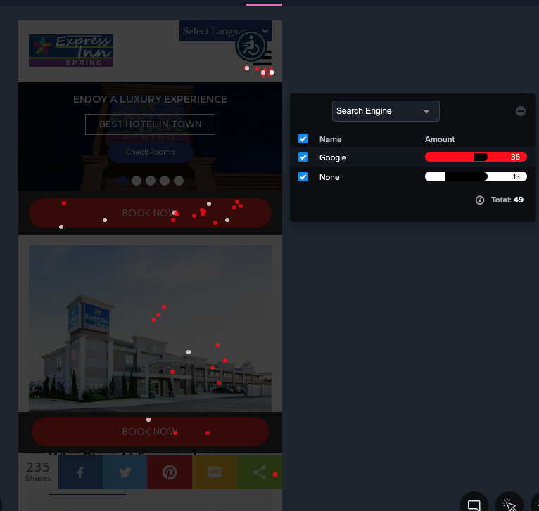

**Device Type**

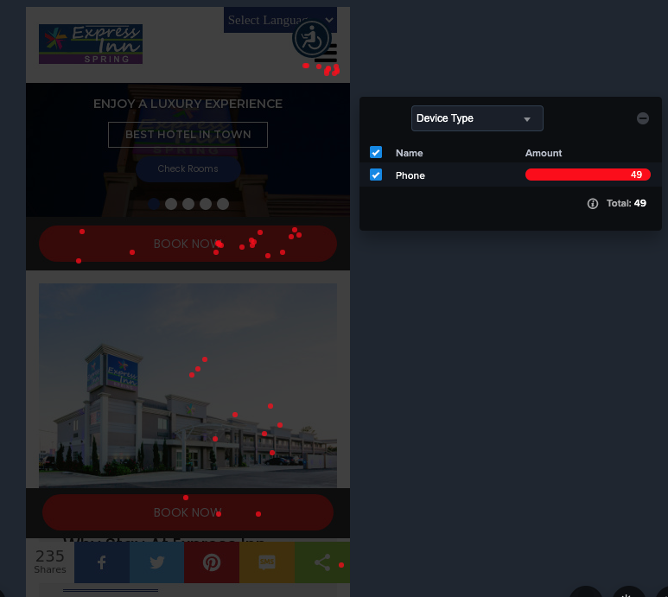

**Operating System**

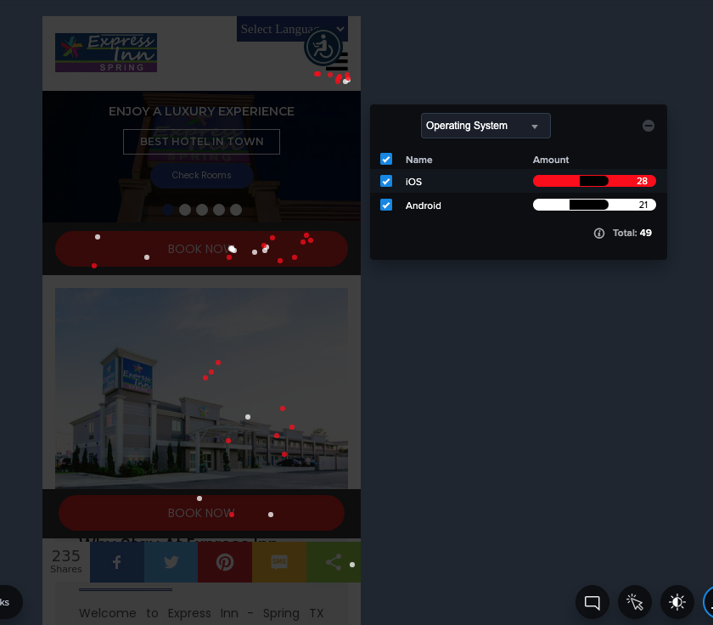

**Browser**

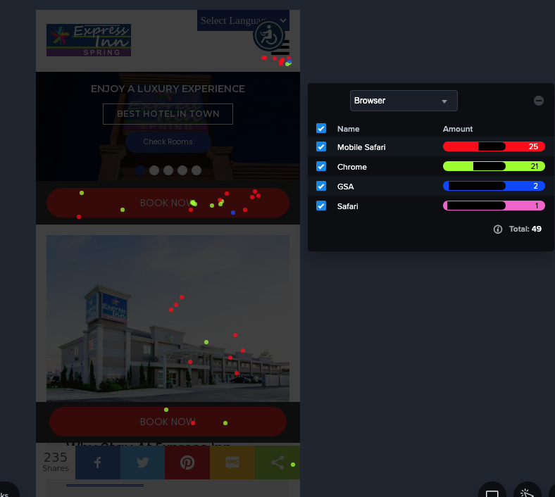

**Day of the Week**

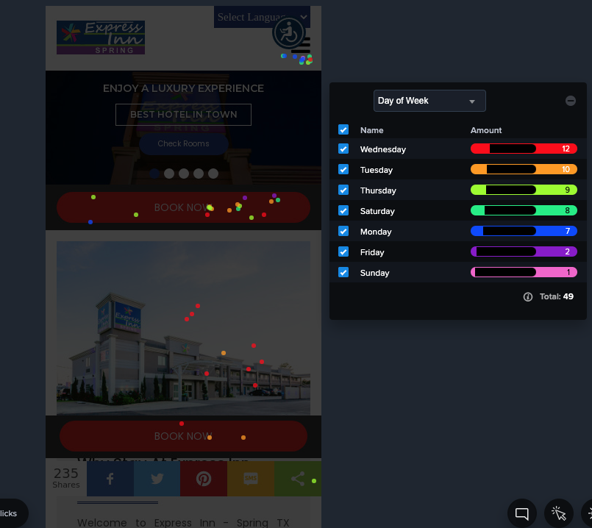

**Time of Day**

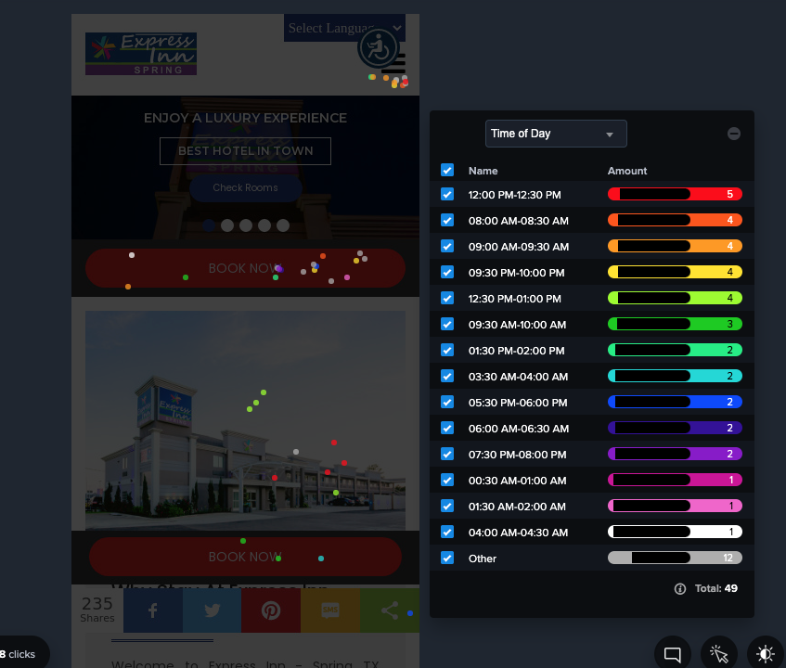

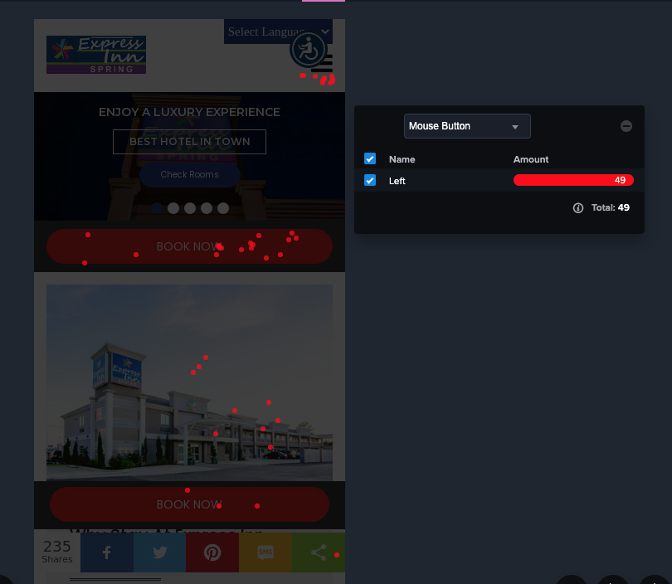**Mouse Butto****n**

# **Desktop Heat Map Report**

**Referrer**

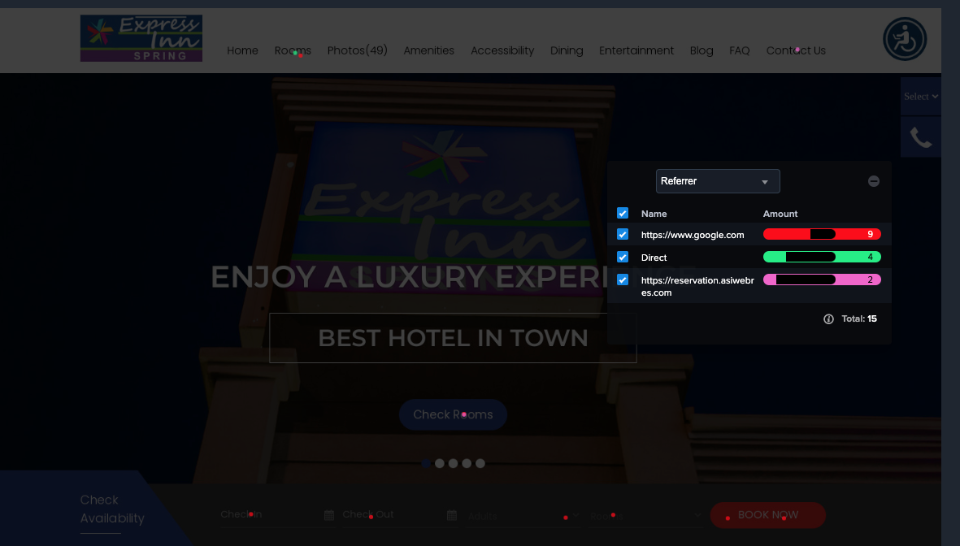

**New Vs Returning**

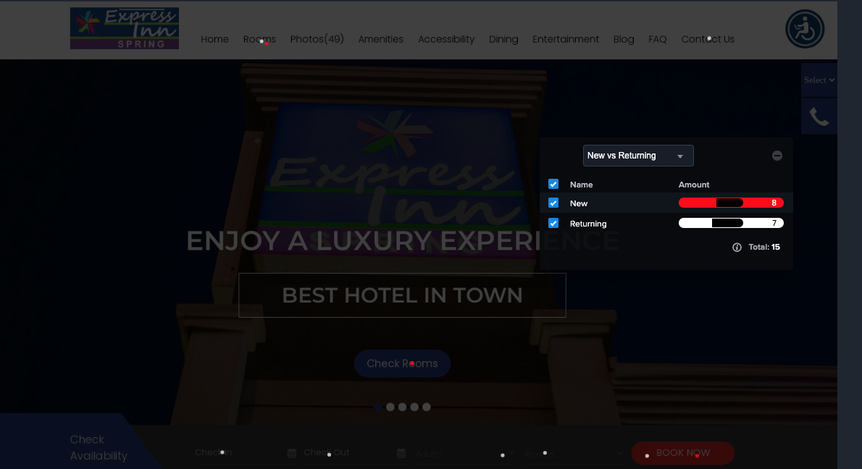

**Search Engine**

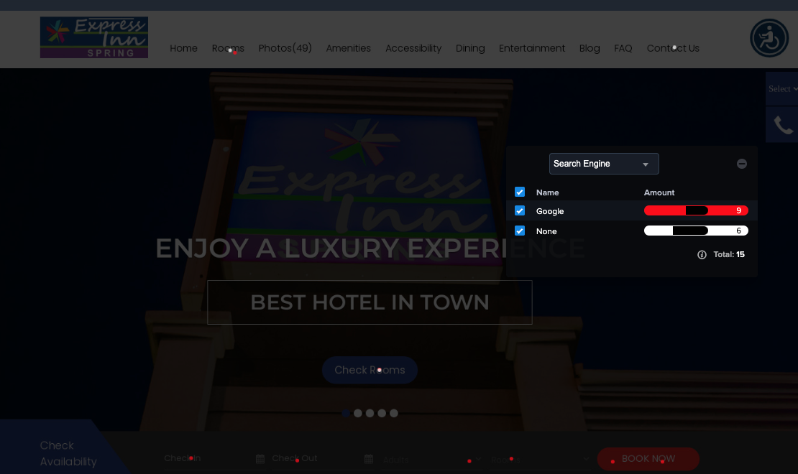

**Operating System**

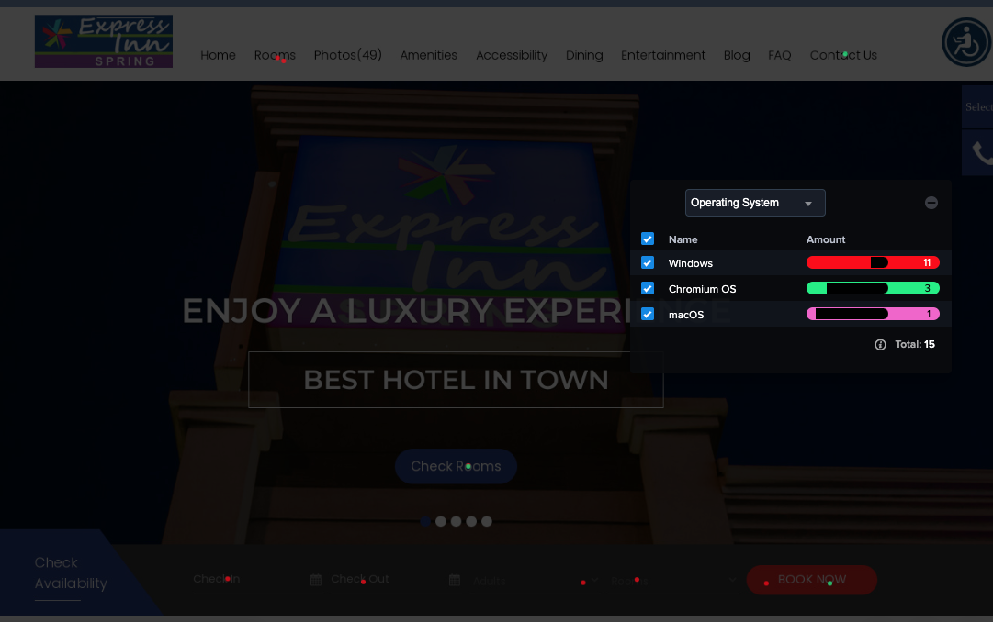

**Browser**

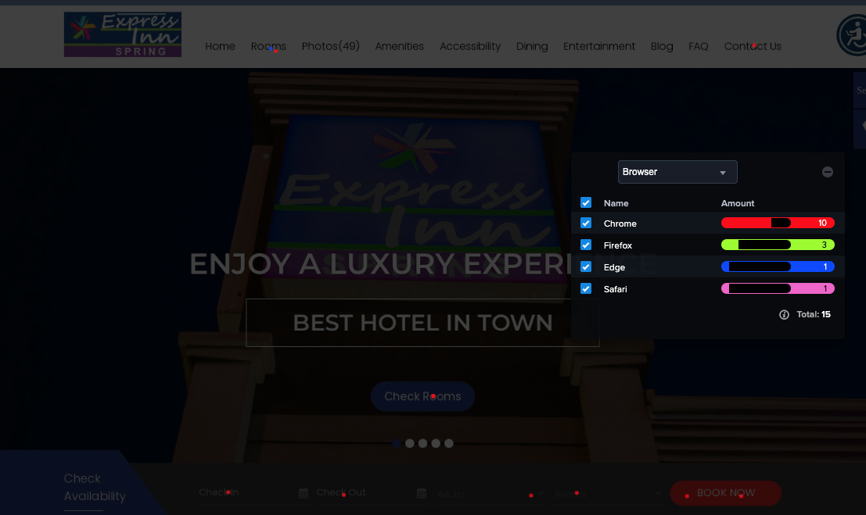

**Day of the Week**

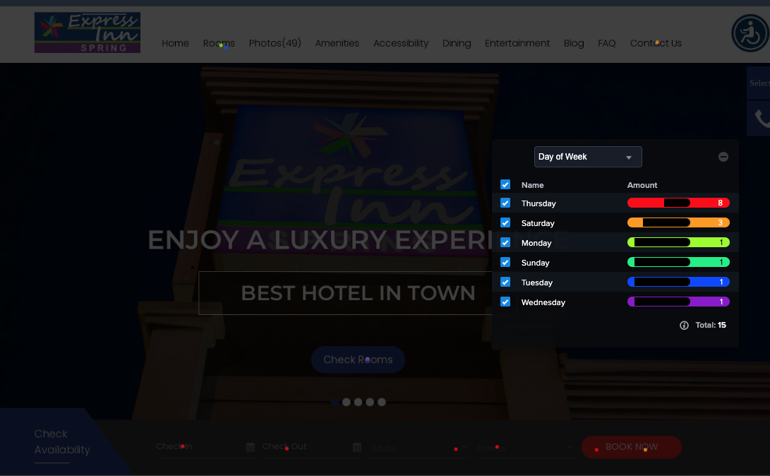

**Time of Day**

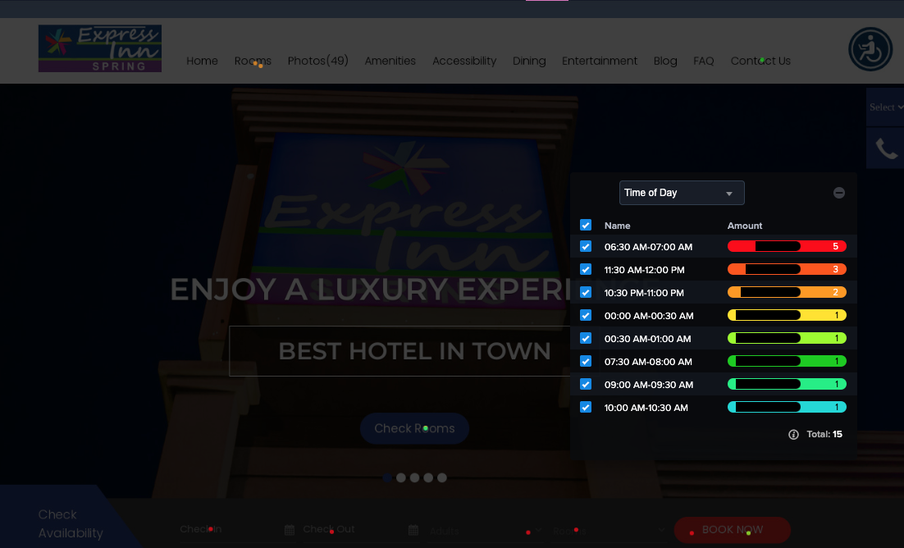

**Time of Clicks**

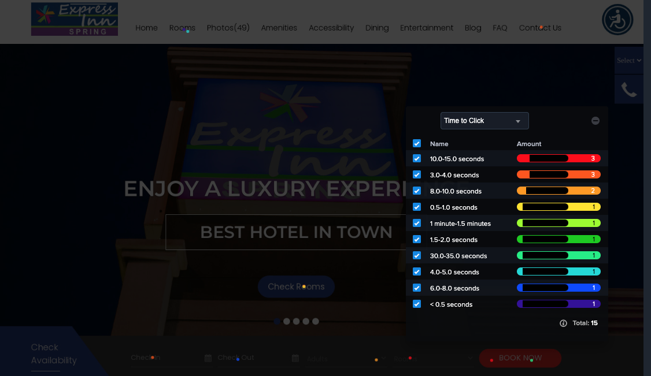

# **Keywords Ranking Report**

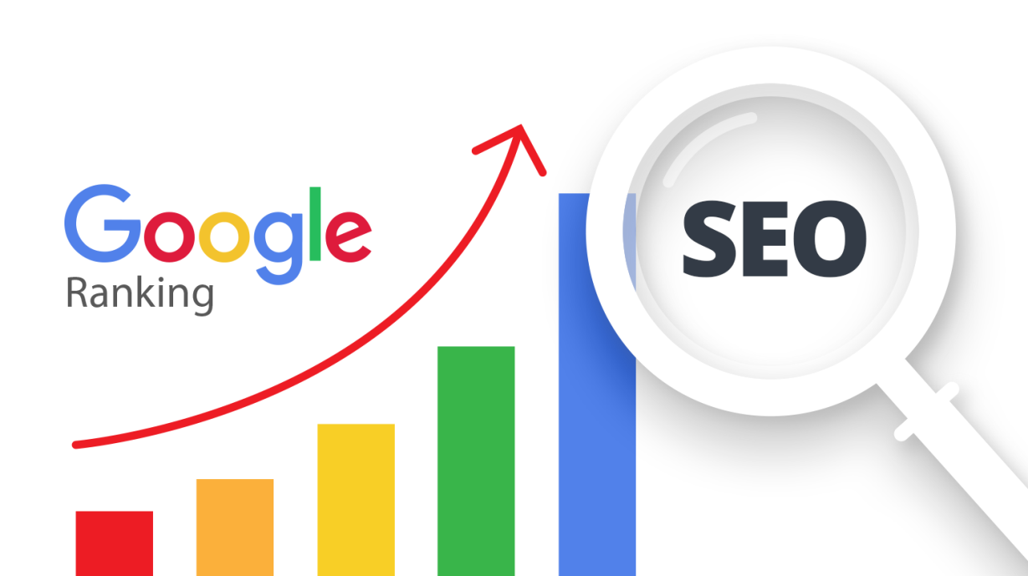

This is keyword Ranking Report; Keyword rank is the position that your website holds or is listed on in Google search results when a user searches that phrase or keyword. Ranking

1 means you are at the top. If you are at number 11, which means that you are on page.

2 of Google as most search results have 10 listings per page.

|  |  |  |  |
| --- | --- | --- | --- |
| [**Keyword Ranking Report www.expressinnspring.com**](http://www.expressinnspring.com/) | | |  |
| **Rank in Google.com** | | |  |
| **Keywords** | **Initial Ranking** | **Previous Ranking** | **Current Ranking** |
| Handicap Accessible Rooms in Spring TX | Not in Serp | 1 | 1 |
| Short Stays Hotel Spring TX | Not in Serp | 1 | 1 |
| Hotel Express Inn | Not in Serp | 1 | 1 |
| Accessible Hotel Spring TX | Not in Serp | 1 | 1 |
| Rooms Spring TX | Not in Serp | 3 | 4 |
| Motels In Spring TX | Not in Serp | 3 | 3 |
| Vacation Hotel in Spring TX | Not in Serp | 1 | 3 |
| Holiday Hotel In Spring TX | Not in Serp | 8 | 8 |
| **Best Holiday Hotel in Spring TX** | Not in Serp | 11 | 12 |
| **Best Hotel Near Old Town Spring** | Not in Serp | 18 | 12 |
| **Closest Hotels To Topgolf** | Not in Serp | 18 | 22 |
| **Affordable Hotel in Spring TX** | Not in Serp | 18 | 16 |
| **Texas Business Hotels** | Not in Serp | 22 | 21 |
| Best Hotels In Spring TX | Not in Serp | 17 | 15 |
| **Accommodation Spring TX** | Not in Serp | 5 | 14 |
| **Discount Hotels Spring TX** | Not in Serp | 24 | 22 |
| **Top Rated Hotel Room Spring TX** | Not in Serp | 15 | 16 |
| **Hotels In Spring TX** | Not in Serp | 34 | 35 |
| **Hotel Near Nrg Stadium** | Not in Serp | Not in Serp | Not in Serp |
| Hotel Offers Springs | Not in Serp | Not in Serp | Not in Serp |
| Hotel Rooms Near Me | Not in Serp | Not in Serp | Not in Serp |
| Hotel Accommodation | Not in Serp | Not in Serp | Not in Serp |
| Affordable Hotels Near Me | Not in Serp | Not in Serp | Not in Serp |
| Hotels In Texas | Not in Serp | Not in Serp | Not in Serp |
| Hotels Near Me | Not in Serp | Not in Serp | Not in Serp |
| Hotel Near Downtown Aquarium | Not in Serp | Not in Serp | Not in Serp |
| Texas Hotel Rooms | Not in Serp | Not in Serp | Not in Serp |
| **Google Insight Keywords** | | |  |
| **Keywords** | **Initial Ranking** | **Previous Ranking** | **Current Ranking** |
| Express Inn Spring | Not in Serp | 1 | 1 |
| Express Inn Spring TX | Not in Serp | 1 | 1 |
| Express Inn Near Me | Not in Serp | 1 | 1 |
| Express Inn | Not in Serp | 1 | 1 |
| Hotel near Six Flags Hurricane Harbor | Not in Serp | 1 | 1 |
| Hotels in Spring | Not in Serp | 1 | 1 |
| The Express Inn | Not in Serp | 1 | 1 |
| Spring TX Hotels | Not in Serp | 22 | 21 |
| Hotels in Spring TX | Not in Serp | 30 | 23 |
| Bayer Park Spring Texas | Not in Serp | Not in Serp | Not in Serp |

# **Keywords Ranking Screenshots**

Keyword Rank : Handicap Accessible Rooms in Spring TX on #1

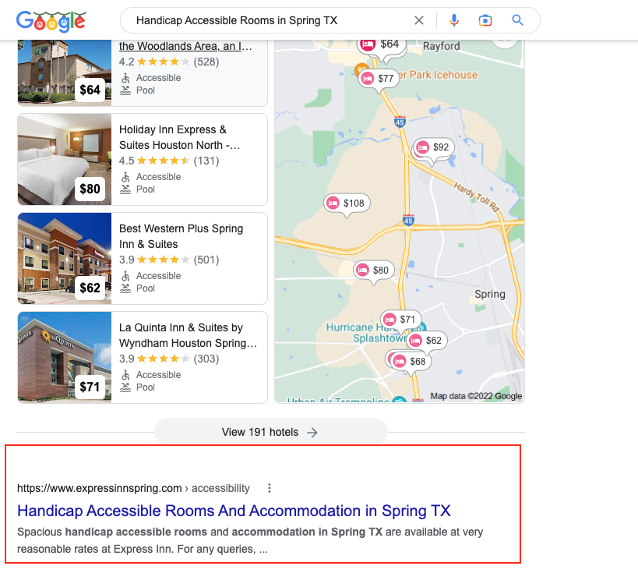

Keyword Rank : Short Stays Hotel Spring TX on #1

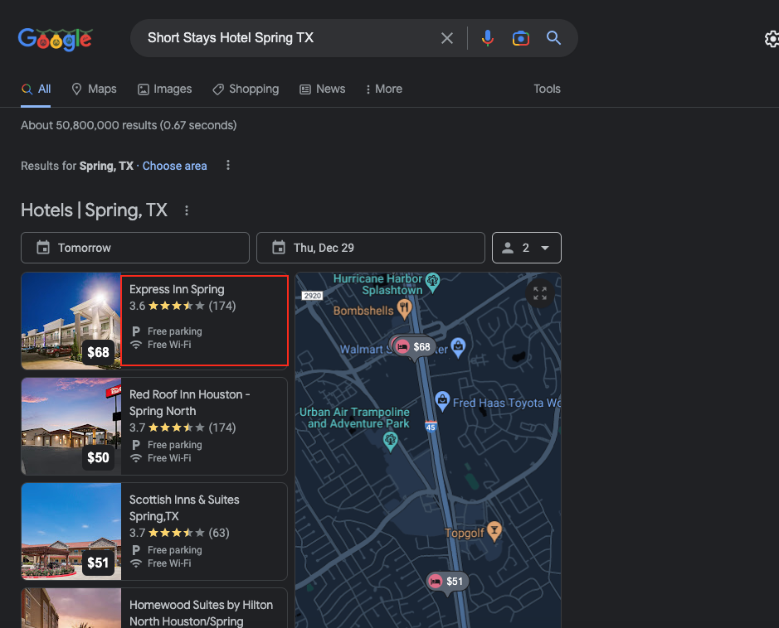

Keyword Rank : Accessible Hotel Spring TX #1

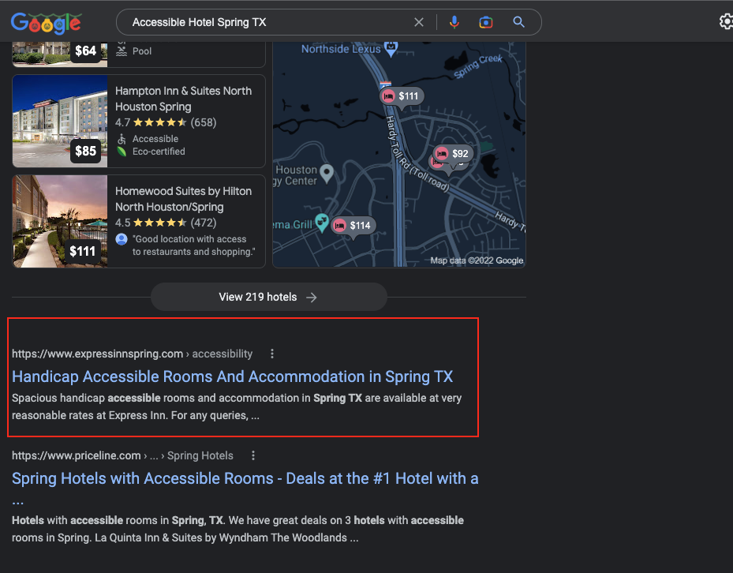

Keyword : **Room spring tx #1**

# 

# **Google Search Console Report**

Google Search Console is a tool where we can check how our website is performing in search engine and can also check our website errors such as loading speed related problem, website is opening properly on various devices.

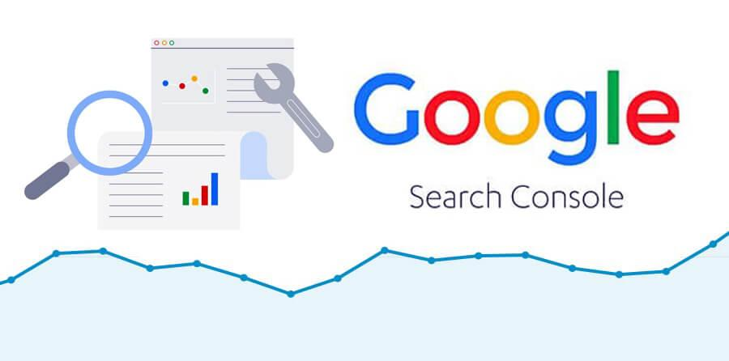

**Performance Overview**

Below is the screenshot that gives us detailed report of total clicks we got from search engine we got total 161 clicks from Google search as per Google Search Console report and to get 161 clicks our website got 19.2k impressions, (Impressions means the number of time your website viewed by the Users). You can also see the Average CTR ( Click through Rate) it’s a rate based on the impression we got and the clicks we got from search engine.

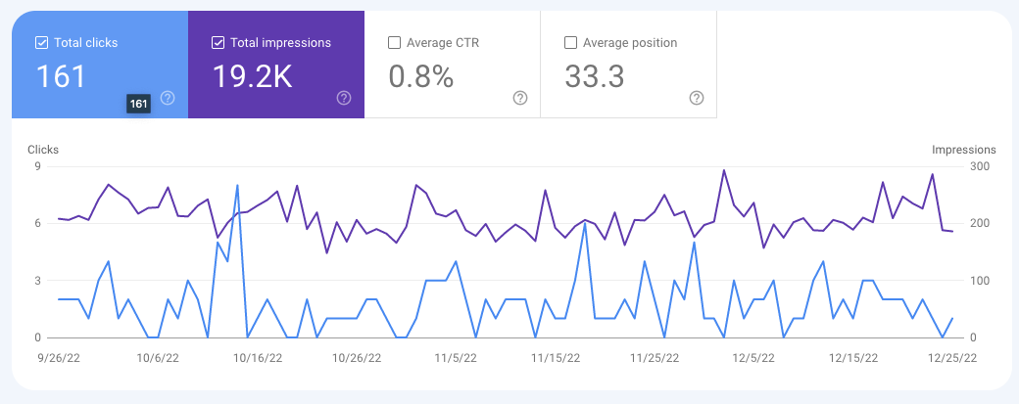

**Top Search Terms**

Below Screenshot shows us the report of top search terms users used in search engine.

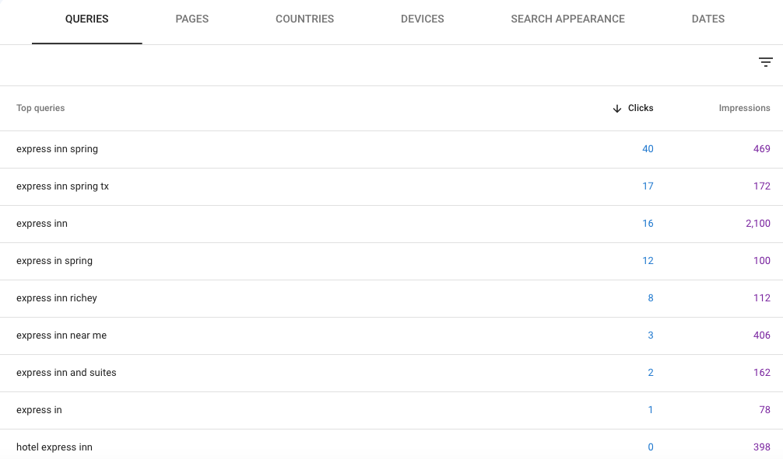

**Top Clicked Pages**

Below is the screenshot that gives us detailed report of on which pages we got impressions from search engine and what number of clicks we got page wise. We can also see the CTR in the report. And Position means your page rank in the SERP(Search engine result page).

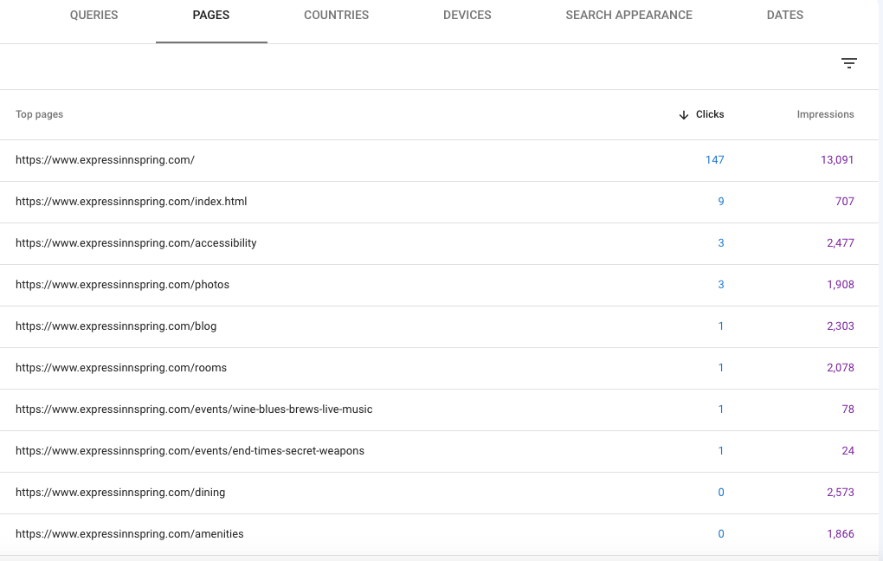

**Countries Based Report**Below is the country wise visitors and other report accordingly, we can see that most of the visitors we got from USA.

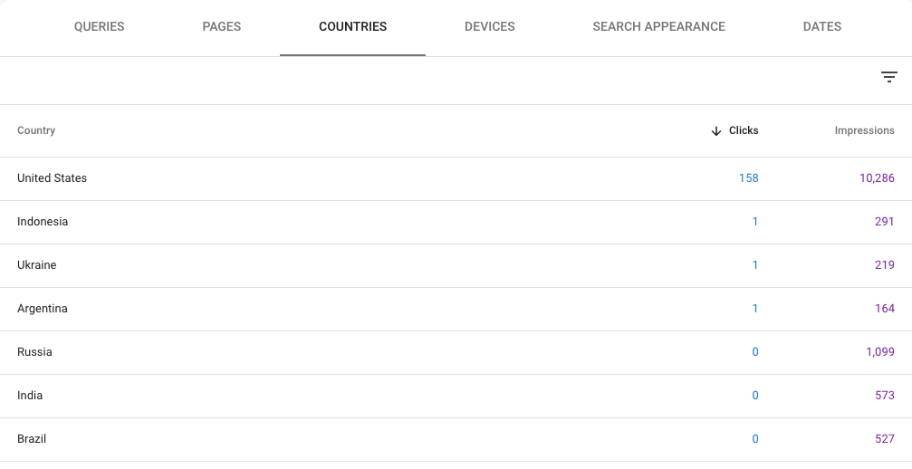

**Device Based Report**

Below is the device wise report that indicates that from which device we got what number of clicks as we can see that in the below report we got good number of clicks from mobile device.

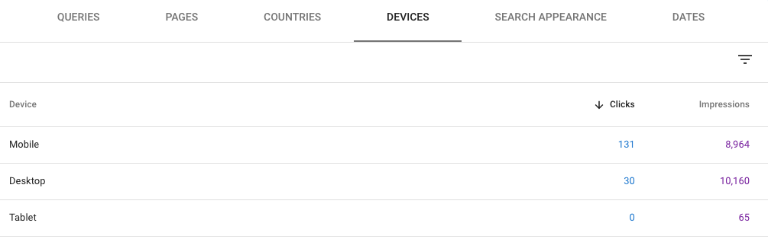

**No Issue Detected in Manual Actions**

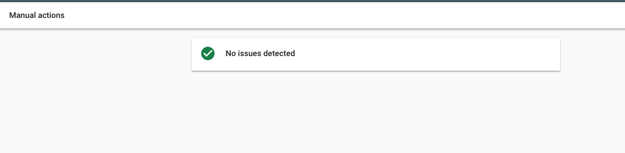This sections show if our website hit by any google algorithm updates. It will be listed here in this section, but there is not such issue on our website.

**No Security Issue**

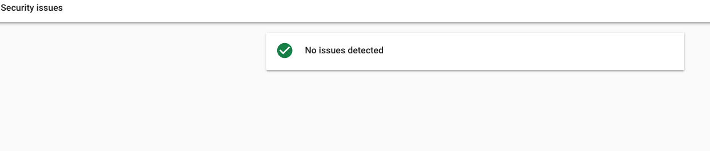There is no security related issue on the website.

**Top Linking Pages**

This section show on which what number of sites our website placed on other website, and we can also see the top linking sites that gives us link from their site.

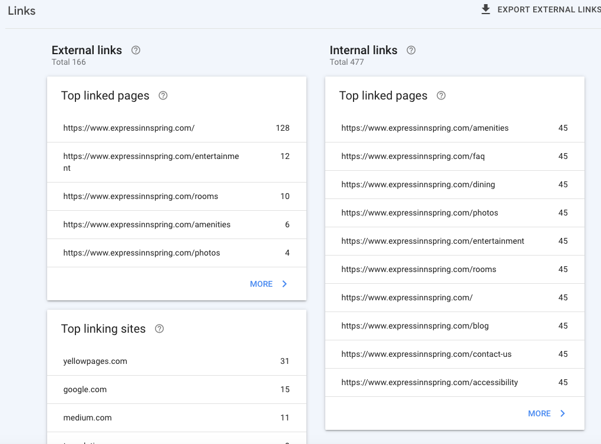

**Sitemap Report**

We can see the sitemap is submitted properly in search console and google has submitted total 58 pages of our website in the search engine.

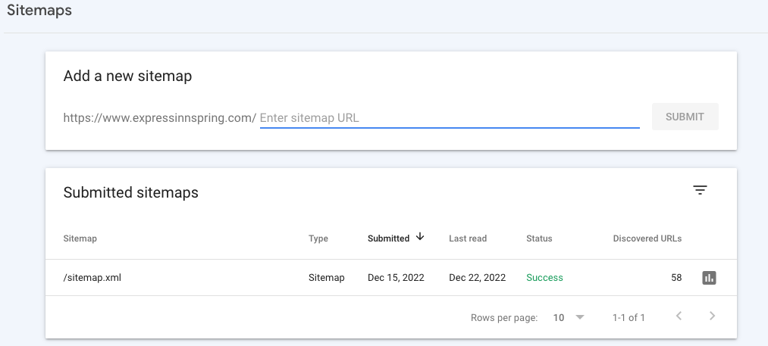

# **Google Analytics Report**

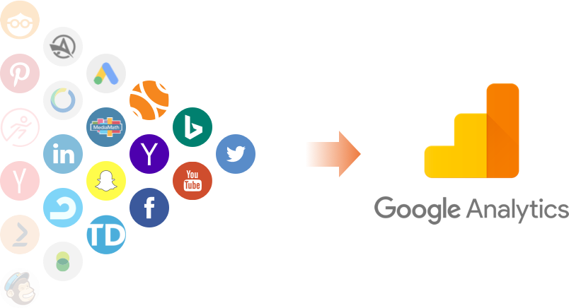

Google Analytics is one of the most popular digital analytics software. It provides valuable insights that can help to shape the success strategy of your business.

It provides statistics regarding the website's visitors. It measures things like site visits, page views, bounce rates, traffic, and more.

**Dashboard Overview**

Below Screenshot is the Acquisition Overview that shows what are the number of new users we got on website, and we can also see the number of organic (from Search engine) visitors we got on the website.

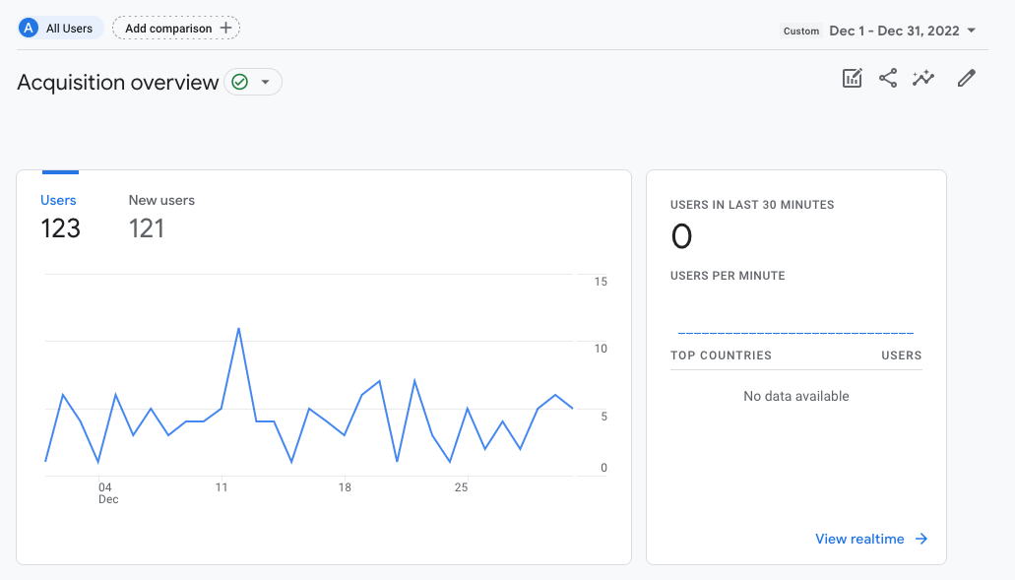

**Engagement Overview**

Below Screenshot is the Engagement Overview that shows which pages users views from our website, we can also see the page title in the screen shot and name of the event.

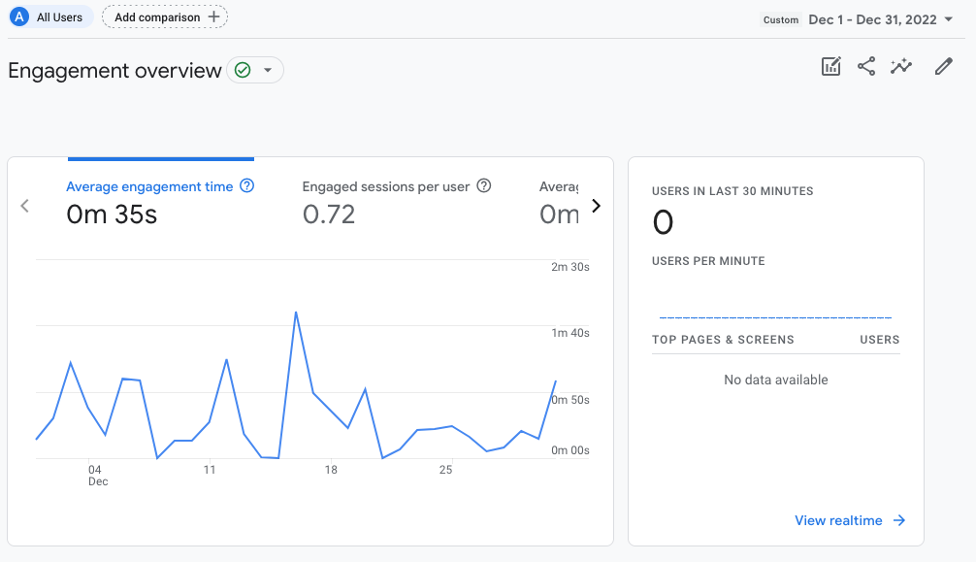

**Events**

Below Screenshot shows us total event count and user engagement and page views, with total new users we got on the website.

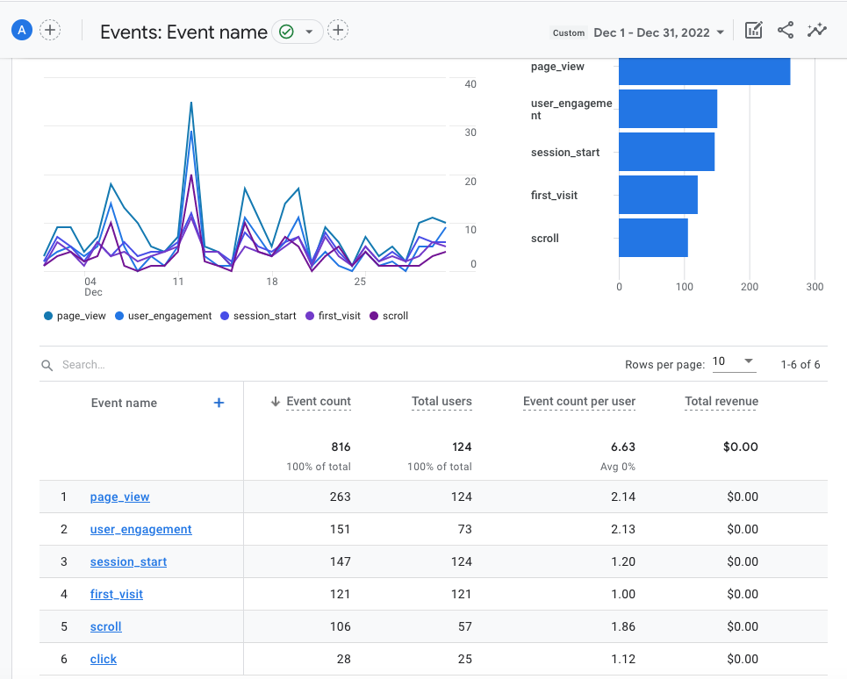

**Most Viewed Pages & Screens**

Below Screenshot is the Pages and Screens snapshot that tells us about how many visitors we got on the website and what pages they have visited on our website. We can also see that how much time they spend on our website.

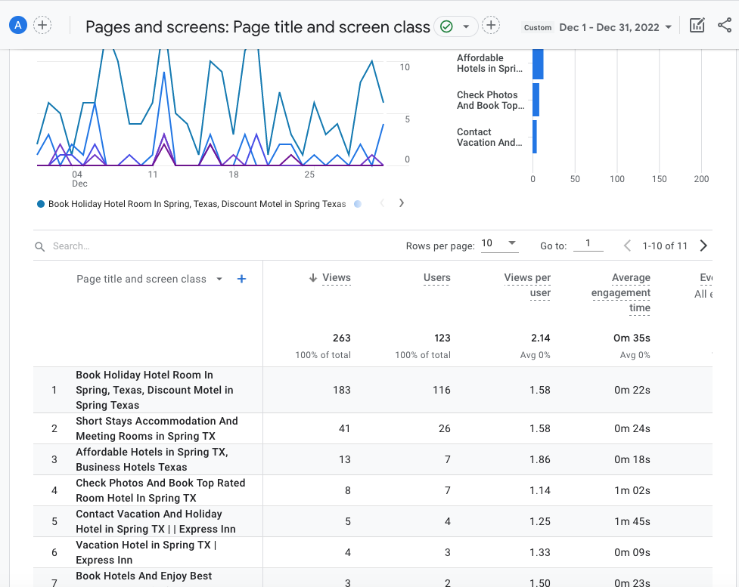

**By Language**

Below Screenshot is that tell what is the user’s language, we can see that users are using English language.

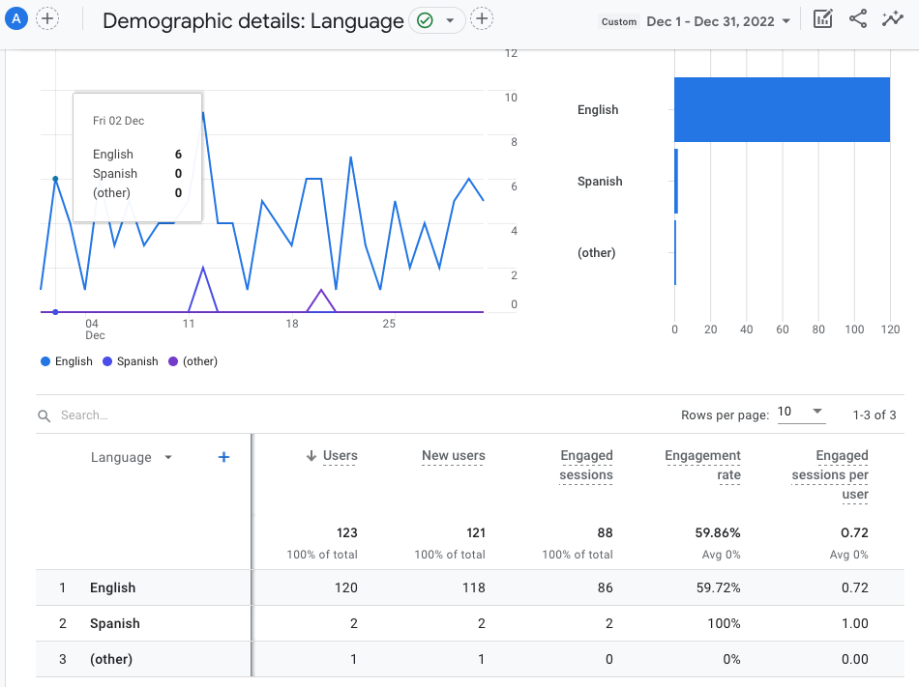

**Tech Overview**

Below Screenshot tells us details about what browsers are being used by the audience. Which browser they are using while visiting your website and we can also see device wise visitors in the below screenshot.

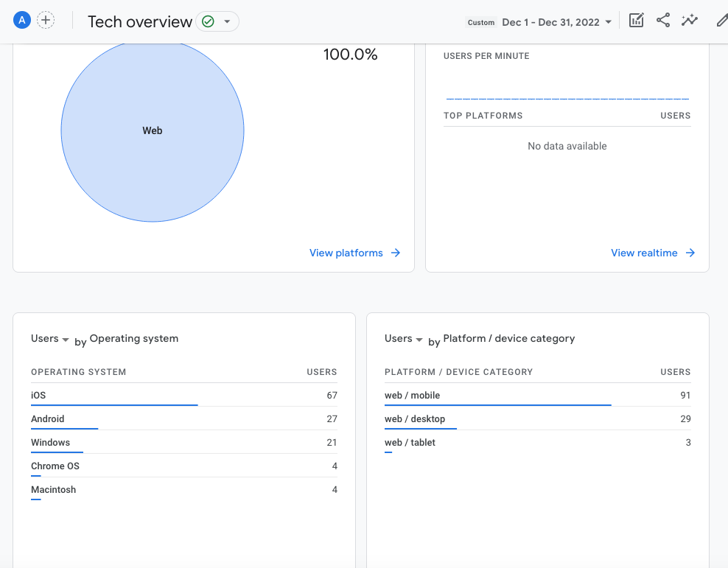

**Device Based Report**

Below screenshot also gives us report about device visitors.

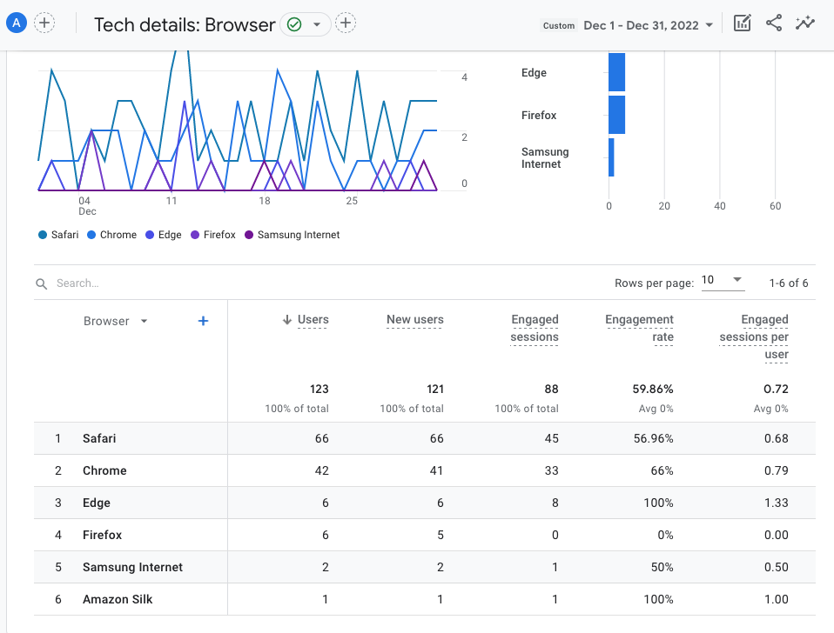

**Browser Based Report**

Below screenshot gives us detail report with graph browser wise, we can see the safari browser is mostly used. We can also see the engagement time in the screenshot.

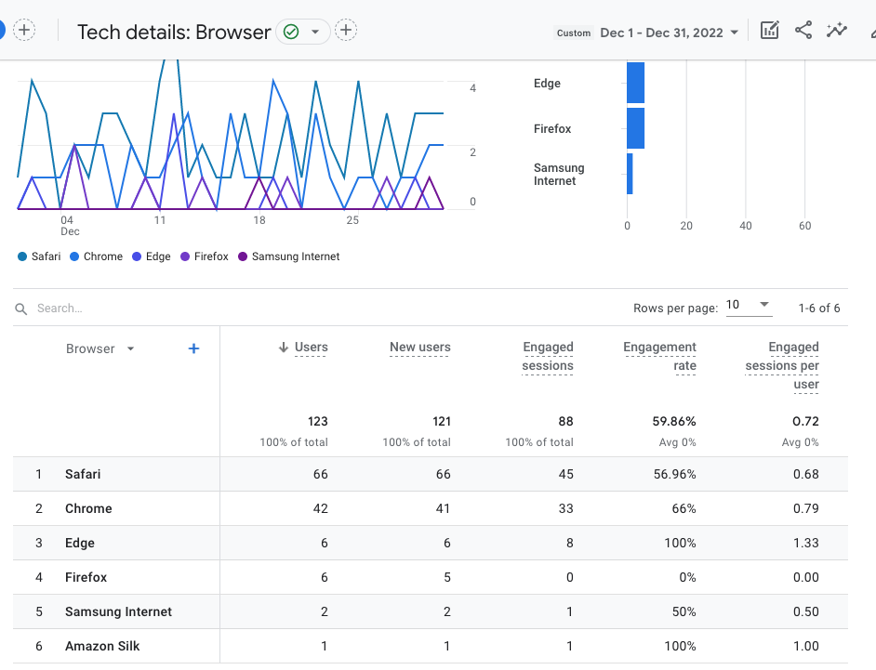

**Traffic acquisition**

Below screenshot gives us complete detail report of from which search engine we got how much visitors. We can see that we got good visitors from google and they are spending good time on our website.

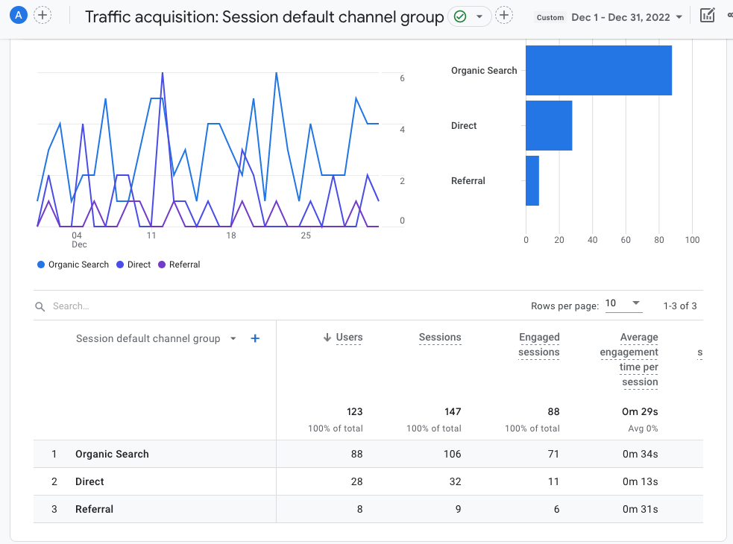

# **Off Page Activities Report**

PDF submission is a technique of sharing PowerPoints presentations on PDF sharing websites like SlideShare. It's an effective way to attract targeted traffic, get quality backlinks and maximize website visibility in SERP Results.

|  |  |  |
| --- | --- | --- |
| **PDF Submission** | **Status** | **Live Link** |
| https://speakerdeck.com/ | Live | https://speakerdeck.com/inn/express-inn-by-accommodation-spring-tx |
| http://www.slideshare.net | Live | https://www.slideshare.net/expressInn/express-inn-by-accommodation-spring-txpdf |
| http://www.edocr.com | Live | https://www.edocr.com/v/qg8n5zdj/expressinn12/express-inn-by-accommodation-spring-tx |
| http://issuu.com | Live | https://issuu.com/expressinnspring/docs/express_inn_by_-_accommodation_spring_tx |
| powershow.com | Live | http://www.powershow.com/view0/9614fc-MGUwO/EXPRESS_INN_By_-_Accommodation_Spring_TX_powerpoint_ppt_presentation |
| www.slideserve.com | Live | https://www.slideserve.com/expressinn/express-inn-by-accommodation-spring-tx |
| https://www.scribd.com/ | Live | https://www.scribd.com/document/614345096/EXPRESS-INN-by-Accommodation-Spring-TX |
| http://www.4shared.com/ | Live | https://www.4shared.com/s/fCH2ge4x_fa |
| https://visual.ly | Live | https://visual.ly/community/Others/business/express-inn-accommodation-spring-tx |



**Guest Posting**

|  |  |  |
| --- | --- | --- |
| **Guest Posting** | **Status** | **live link** |
| www.fc2.com | live | https://expressinnusa.blog.fc2.com/blog-entry-5.html |
| tumblr.com | live | https://at.tumblr.com/expressinn1/tips-on-the-most-proficient-method-to-pick-the/c9omt777j55m |
| https://penzu.com | live | https://penzu.com/p/7b8e0c4d |
| https://wakelet.com/ | live | https://wakelet.com/wake/TEnYxwkDO9C1mbl2pY90W |
| https://www.blogger.com/ | live | https://expressinnspring.blogspot.com/2022/12/what-to-look-for-when-booking-hotels.html |



Profile creation is one SEO off page link building technique in which we create your businesses’ profile on different platforms such as blogs posting sites, social networking platforms, web 2.0 websites and more. This strategy helps increasing the branding over the search engine and boosts visibility for your brand.

You can check below all those links that we have created under Profile creation.

|  |  |  |
| --- | --- | --- |
| **Profile Creation** | **Status** | **Live Link** |
| https://kaalama.org/ | Live | https://kaalama.org/Expressinn |
| https://peatix.com/ | Live | https://peatix.com/user/15028068/view |
| https://uniquegram.com | Live | https://uniquegram.com/profile/Expressinn |
| https://www.recentstatus.com/ | Live | https://www.recentstatus.com/Expressinn |
| https://www.nasseej.net/ | Live | https://www.nasseej.net/Expressinn |



Classifieds is an online advertising technique used to promote the business and website.

Classified Submission is an off-page SEO technique that helps to increase the genuine traffic within your target location.

|  |  |  |
| --- | --- | --- |
| **Classified** | **Status** | **Live Link** |
| http://www.usnetads.com/ | Live | http://www.usnetads.com/view/item-131577474-Best-Top-Rated-Hotel-Rooms-Near-Old-Town-Spring-TX.html |
| http://www.hot-web-ads.com/ | Live | http://www.hot-web-ads.com/view/item-14433015-Best-Holiday-Hotel-in-Spring-TX-By-Express-Inn-Spring.html |
| https://www.postandcore.com/ | Live | https://www.postandcore.com/classifieds/texas/texas-other/business-services/vacation-and-travel/best-holiday-hotel-in-spring-tx-by-express-inn-spring-75847/ |
| http://www.canetads.com/ | Live | http://www.canetads.com/view/item-3173763-Best-Top-Rated-Hotel-Rooms-Near-Old-Town-Spring-TX.html |
| adpost4u.com | Live | https://www.adpost4u.com/services/travel-tourism/174002/best-vacation-hotel-in-spring-tx |



Social bookmarking is one off-page SEO activity that helps to increase the customer traffic and generate high quality follow backlinks.

|  |  |  |
| --- | --- | --- |
| **Bookmarking** | **Status** | **Live Link** |
| https://gab.com/ | Live | https://gab.com/expressInns/posts/109516131291246249 |
| https://gab.com/ | Live | https://gab.com/expressInns/posts/109516131841552217 |
| https://gab.com/ | Live | https://gab.com/expressInns/posts/109516132336410991 |
| https://gab.com/ | Live | https://gab.com/expressInns/posts/109516133099542349 |
| https://gab.com/ | Live | https://gab.com/expressInns/posts/109516133610179418 |
| https://flipboard.com | Live | https://flip.it/Os.lt_ |
| https://flipboard.com | Live | https://flip.it/nkOYHS |
| https://flipboard.com | Live | https://flip.it/v0v3z8 |
| https://flipboard.com | Live | https://flip.it/gBGPMX |
| https://flipboard.com | Live | https://flip.it/-3tN-v |



|  |  |  |
| --- | --- | --- |
| **Local Listing** | **Status** | **Live URL** |
| https://www.magcloud.com/ | Live | https://www.magcloud.com/user/expressinnspring |
| https://startupxplore.com/ | Live | https://startupxplore.com/en/person/express-inn-spring |
| https://www.adskhan.com/ | Live | https://www.adskhan.com/?post_type=gd_place&p=77469&preview=true |
| https://www.jsdirectory.com/ | Live | https://www.jsdirectory.com/social/Expressinn |
| https://biztime.com.vn/ | Live | https://biztime.com.vn/Expressinn |



Quora is a platform where we interact with the audience who is talking about hotels, we recommend your hotel while interacting with them.

|  |  |  |
| --- | --- | --- |
| **Quora** | **Status** | **Live Link** |
| https://www.quora.com | Live | https://www.quora.com/Are-there-any-cancellation-charges-for-hotel-bookings/answer/ExpressInn-1?prompt_topic_bio=1 |
| https://www.quora.com | Live | https://www.quora.com/What-are-extra-charges-on-hotel-booking/answer/ExpressInn-1?prompt_topic_bio=1 |
| https://www.quora.com | Live | https://www.quora.com/Do-hotels-charge-for-cleaning-after-check-out-time/answer/ExpressInn-1?prompt_topic_bio=1 |
| https://www.quora.com | Live | https://www.quora.com/What-are-the-benefits-of-booking-a-stay-in-a-resort/answer/ExpressInn-1?prompt_topic_bio=1 |
| https://www.quora.com | Live | https://www.quora.com/How-do-you-book-a-hotel-by-the-hour/answer/ExpressInn-1?prompt_topic_bio=1 |



|  |  |
| --- | --- |
| Facebook Post | Count |
| Total Post | 8 |

# 

# **Thank you**